Nike Free x Metcon

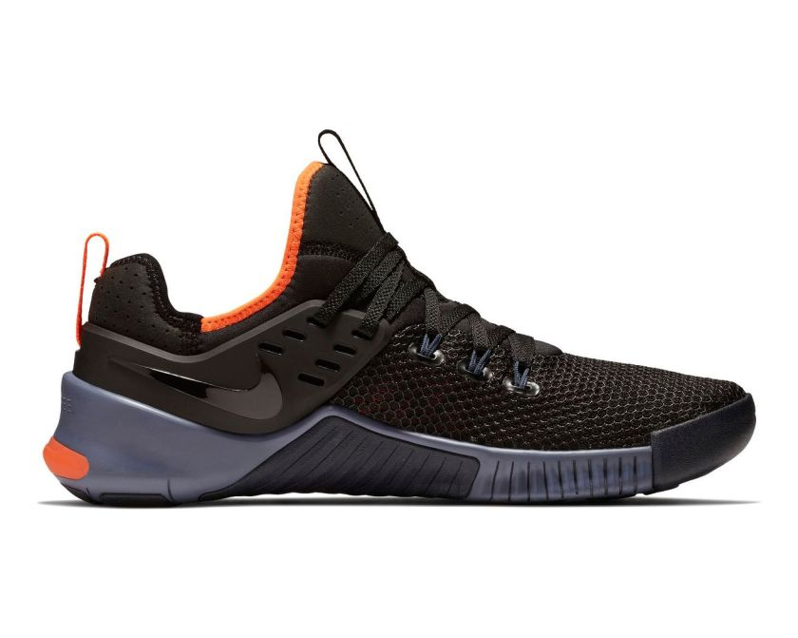

Product code: 1011

The Nike Free x Metcon Training Shoe combines the lightweight flexibility of Nike Free with the durability and stability of Nike Metcon shoes—which means it can stand up to short runs, boot camps, strength training and the WOD.

# Nike Free TR V8

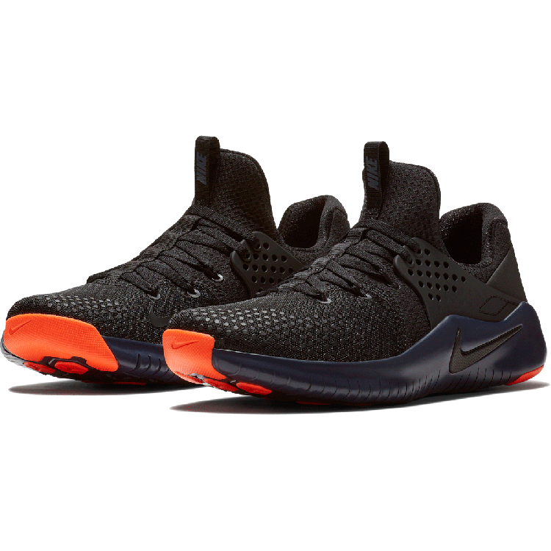

Product code: 1012

Designed for natural movement and lockdown during intense workouts, the Nike Free TR V8 Men's Training Shoe features a flexible sole pattern and a stabilising wing that wraps your heel for a supportive feel.

# Nike Metcon 4

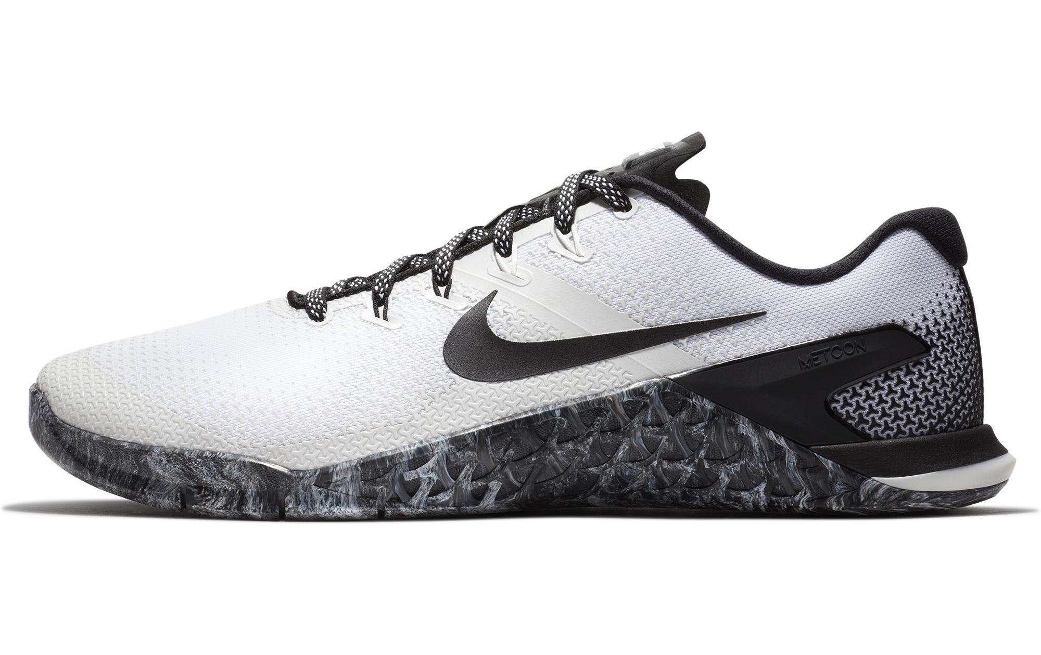

Product code: 1013

The Metcon 4 Men's Cross Training, Weightlifting Shoe provides a strong, stable base, flexible support and extreme durability for a wide range of training activities, from sprints and sled pushes to lifting and rope climbing. A new textured mesh makes it stronger, lighter and more durable than any Metcon—ever.

# Nike Lunar Prime Iron II

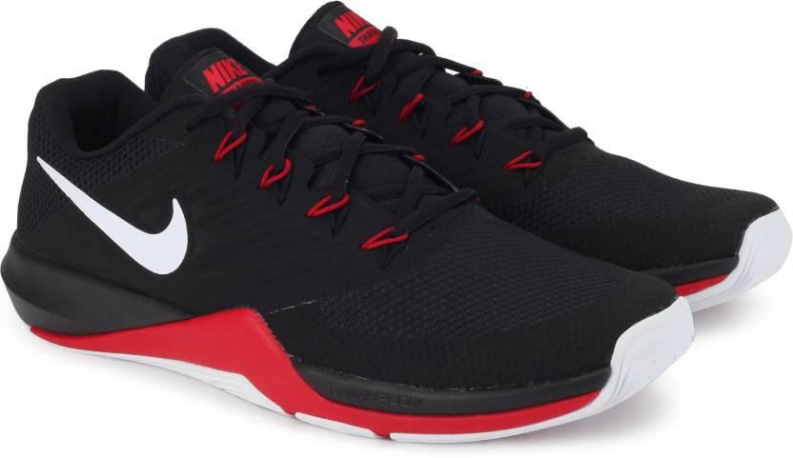

Product code: 1014

The Nike Lunar Prime Iron II Men's Training Shoe features Flywire that integrates with the laces for locked-down support and a lightweight foam midsole for comfort during your most explosive workouts.

# Nike Zoom Train Command

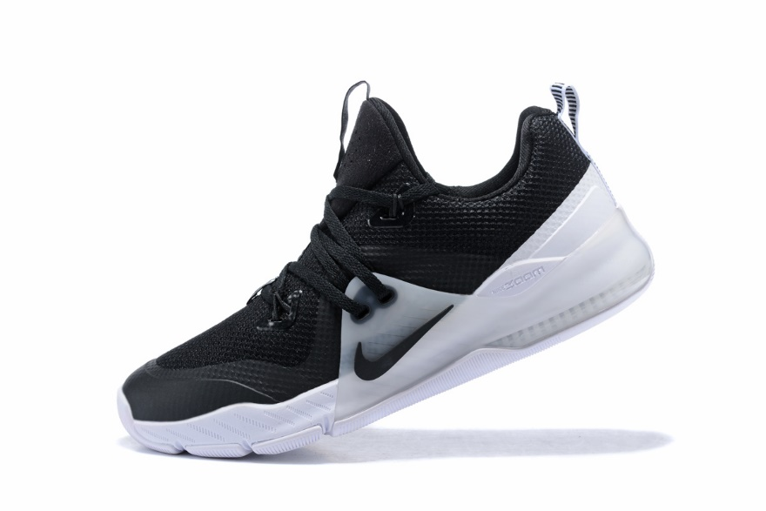

Product code: 1015

The Nike Zoom Train Command Men's Bootcamp, Gym Shoe provides locked-down support and Zoom Air cushioning for increased responsiveness during your workout.